Monte Barro Regional Park: biodiversity, history and landscape

Mount Barro is a relatively low mountain on the edge of the Lombardy Prealps in the lake region not far from Lake Como. The mountain is well known for its floristic biodiversity which includes stenoendemic, alpine and sub-mediterranean species. Its richness is related to the geology and topography of the territory, to past glacial events and to human activities in historical times. The area hosts the largest Gothic settlement ever unearthed in Italy (V-VI cen.), attesting the role of man in landscape transformation through the centuries.
Nowadays Mount Barro is a Regional Park and a Special Area of Conservation (SAC) according to the European Union's Habitats Directive (92/43/EEC). The Park has accepted the challenge of preserving and managing this territory, which is threatened by abandonment and woodland expansion, in order to valorise its naturalistic, historical and cultural heritage.

Responsible: Monte Barro Regional Park and Native Flora Centre of Lombardy (Parco Monte Barro e Centro Flora Autoctona della Regione Lombardia: Roberta Ceriani and Mauro Villa)

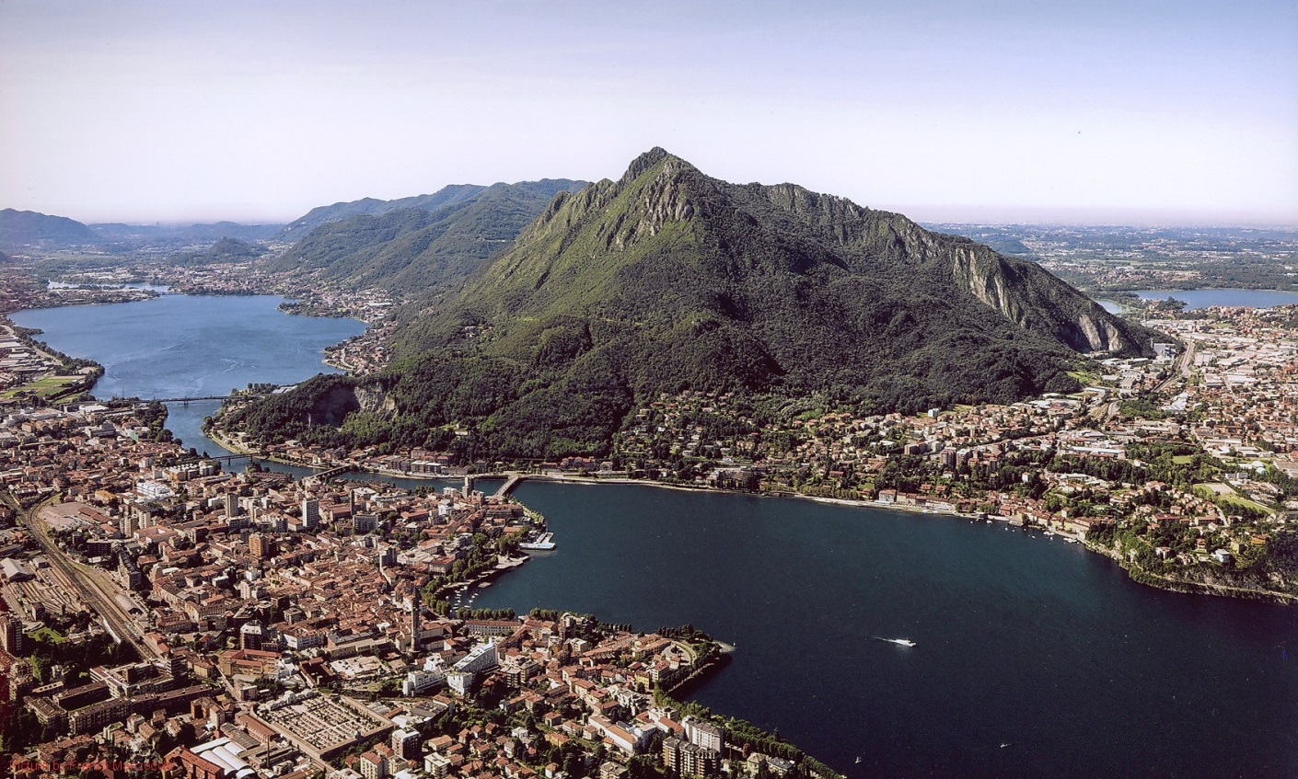

Excursion
High biodiversity calcareous grasslands will be the focus of the first part of the excursion during the morning: Monte Barro Regional Park has been trying to reverse the current fragmentation and reduction of this habitat for years, after the end of traditional regular mowing.
After lunch the Archaeological Gothic Site of Piani di Barra will be visited together with the Roccolo di Costa Perla, a complex, traditional songbird-hunting structure composed of trees and grasslands artificially positioned and shaped, and constantly pruned, mown or cleaned (now converted into an ornithological scientific outpost). Later on, the visit will continue at the Native Flora Centre of Lombardy, a regional institution devoted to the preservation and production of native species. The excursion will end in a quarry partially restored with native plants.

