Rural landscapes between tradition and innovation. Linking nature, biocultural landscape and food production in the ‘Langhe, Roero and Monferrato vineyards landscape’ UNESCO (Piedmont)

One day tour in and around the ‘Langhe, Roero and Monferrato vineyards landscape’ recognized by UNESCO as Cultural heritage in 2014. Participants will jump in the past, discovering the ‘Colline del mare’ (Sea hills) - a Paleontological district dating in Pliocene – and visiting the Underground Cathedrals (XIX century) - ancient wine cellars famous worldwide. Then they will visit the universal valued vineyards landscape discussing on the management plan and future challenges, due to the last plant deseases, low impact cultivation system and increasing touristic pressures.

Responsible: Federica Larcher

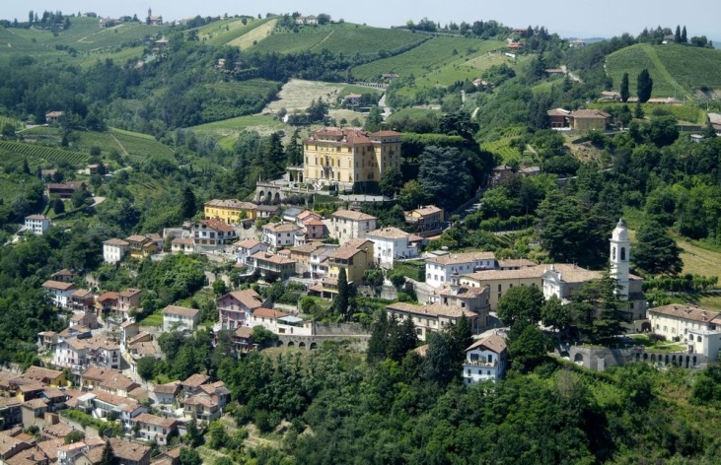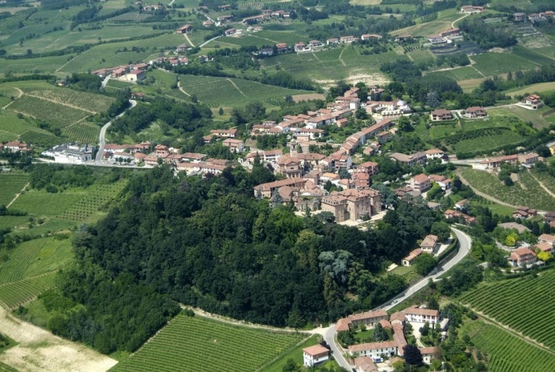
Pictures: Marc Cooper

References:
GULLINO P., LARCHER F., 2013. Integrity in UNESCO World Heritage Sites. A comparative study for rural landscapes. Journal of cultural heritage 14:389-395.
LARCHER F., NOVELLI S., GULLINO P., DEVECCHI M., 2013. Planning rural landscapes: a participatory approach to analyse future scenarios in Monferrato Astigiano (Piedmont, Italy). Landscape research 38(6):707-728.
Gullino P., Beccaro G., Larcher F., 2015. ASSESSING AND MONITORING THE SUSTAINABILITY IN RURAL WORLD HERITAGE SITES. SUSTAINABILITY 7(10):14186-14210.

